F=4*p-0*lk+10*w-10*t_level-2*est-1*comp_t

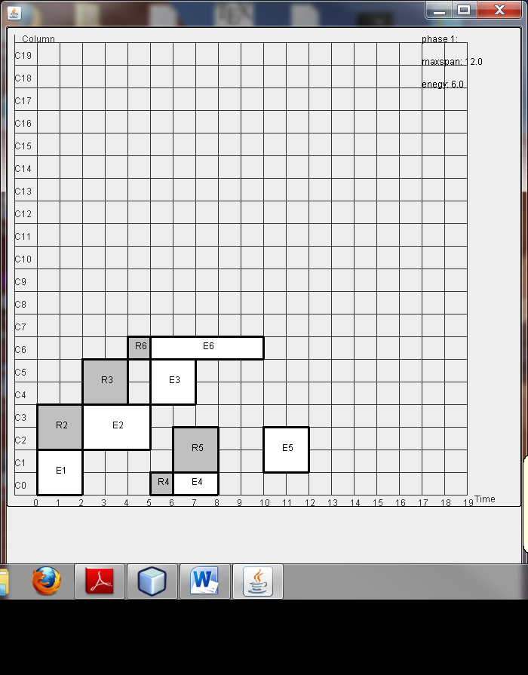

Example 1- without lk placement

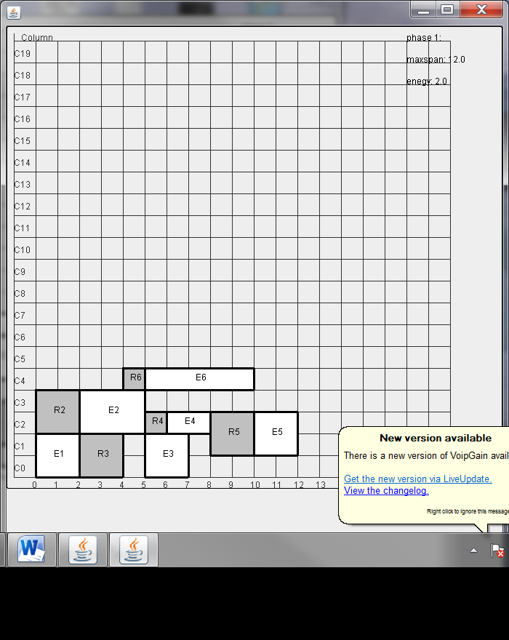

Example 1- 10*lk + (10-450)*est

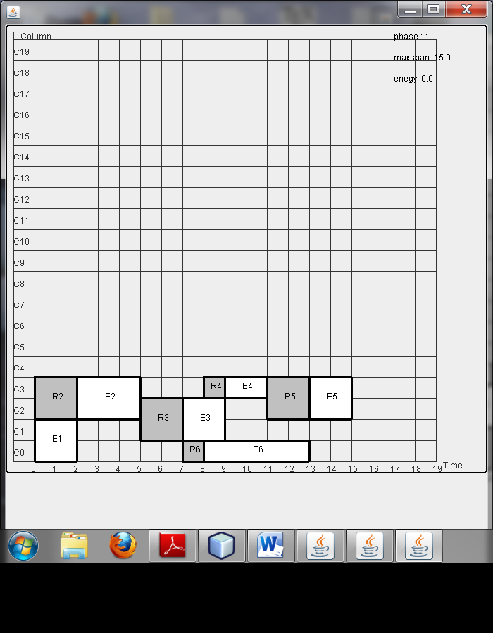

Example 1- 10*lk + (1-5)*est

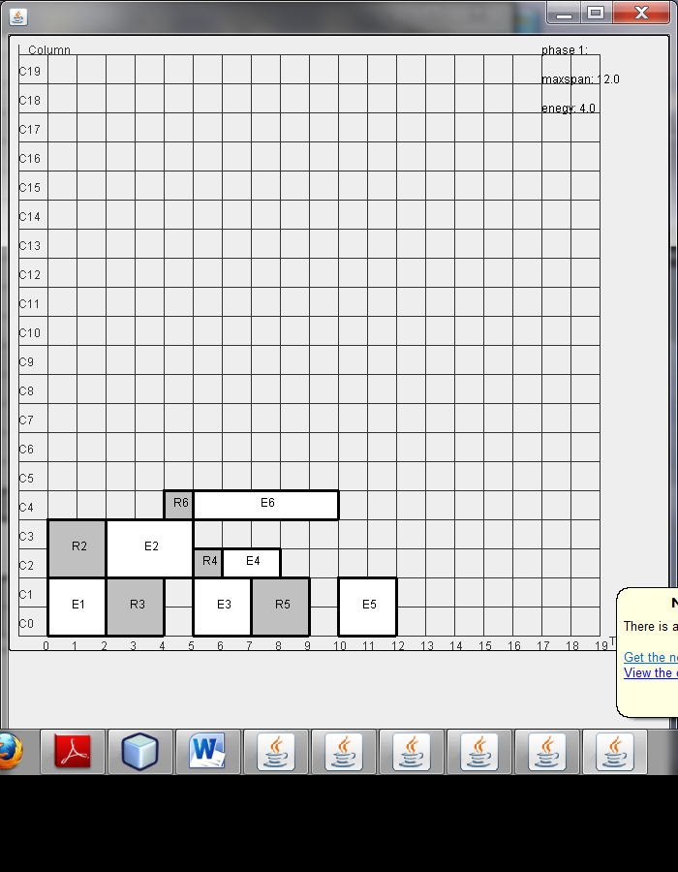

Example 1- 0*lk + (10-450)*est